Register Map LMP91000
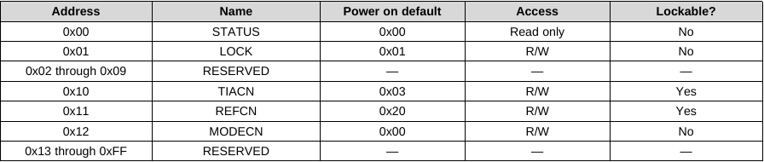
STATUS
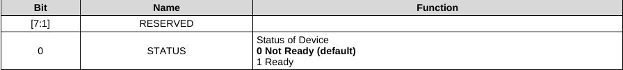
LOCK
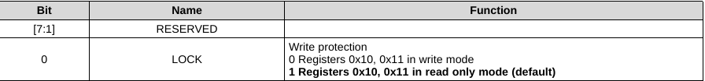
TIACN
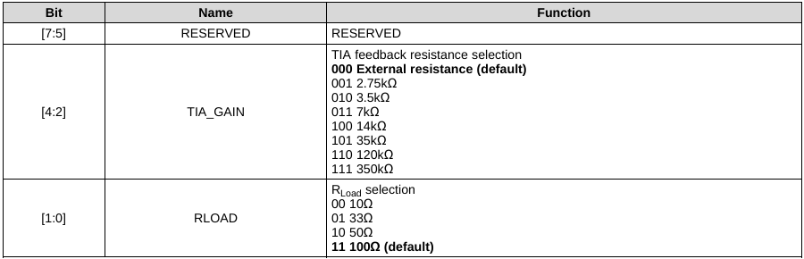
REFCN
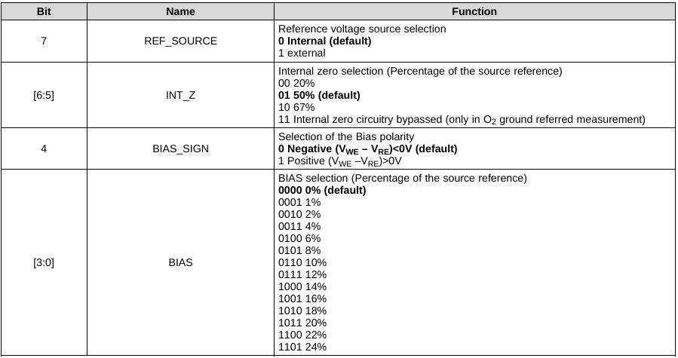
MODECN
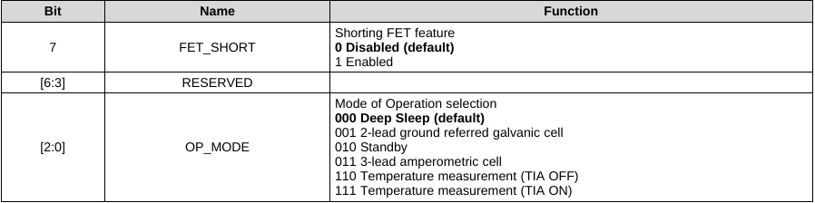
When the LMP91000 is in Temperature measurement (TIA ON) mode, the output of the temperature sensor is present at the VOUT pin, while the output of the potentiostat circuit is available at pin C2.

